Summary

* Jose Baeza
* Ariel May
* Nicolas Gala
* Leonardo Hernandez
* Presentation url:  
  <https://drive.google.com/open?id=1H9wU5mGMJlvGhAy9QabV35GjjQJ8JOcW>
* Problematic description and relevant information:  
  People with hearing limitations have a hard time developing analytical thinking and finding solutions to problems related to mathematics and literary.  
  We are currently working with CAM Multipurpose Center number 12 with students between 12 and 18 years of age, as this institution provides advice to reinforce topics seen in their regular schools, and although there are children of a mature age, they still have difficulties in being able to realize and understand topics of analysis and understanding.
* URL to documents related to the activities/task/tickets scheduled so far:  
  <https://github.com/JoseBaezaP/IHC/tree/master/Planning>
* Data collection instruments and data collected:  
  The blank survey, scans of the answered surveys and graphs can be found in the next repository link:  
  <https://github.com/JoseBaezaP/IHC/tree/master/Entrevistas>
* Draft of personas:  
  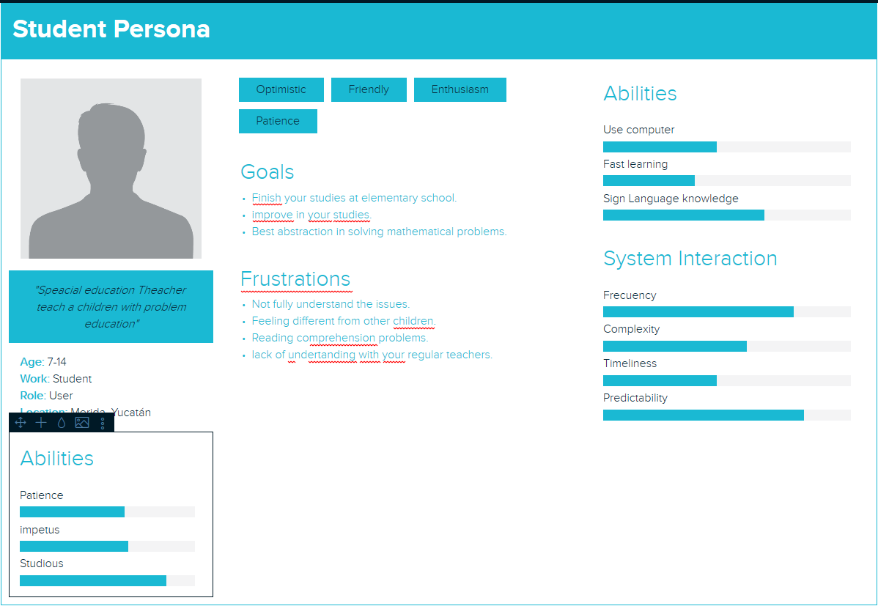  
  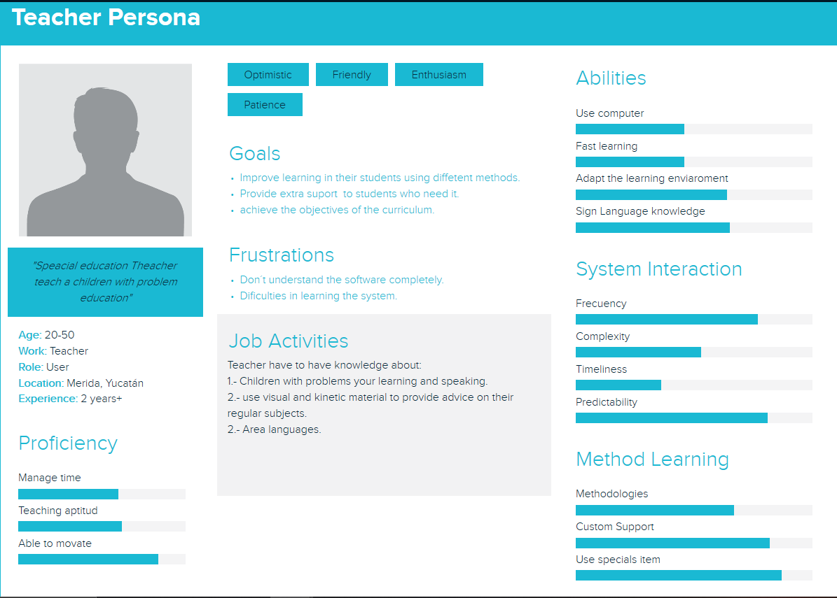
* Initial list of requirements:  
  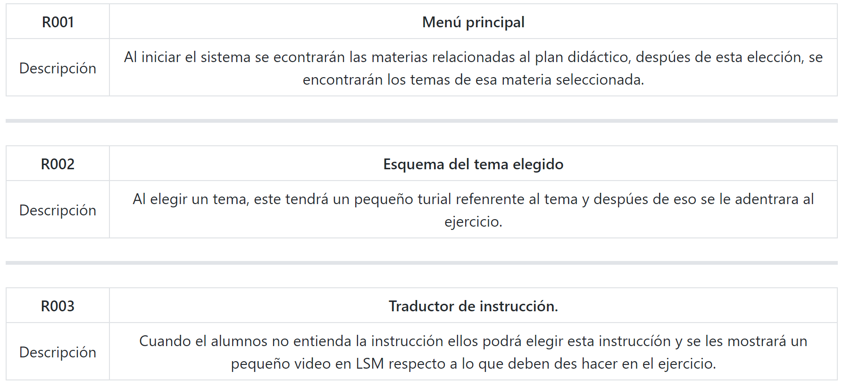
* Table with personal contributions:  
  The way in which we decided to measure the work done between us was as follows:   
   (%) Percentage worked (number of activities carried out + attended meetings / number of total assigned work + total meetings)/4  
  Then as we had 5 meetings and 3 activities, the table ended as follows:  
  